2200032991 Spring Core_Maven
Exercise 9: Creating a Spring Boot Application

Out put :-
To run the application mvn spring-boot:run
we use GET POST to see the out put
http://localhost:8080/books
you get this
[ ] as output
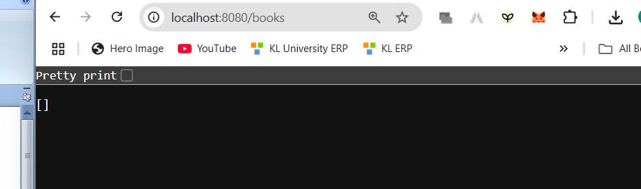

If we do more changes
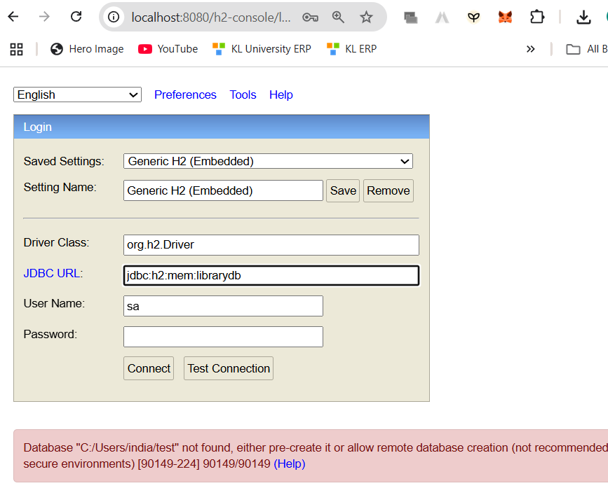

In the url use what you kept in application.properties.
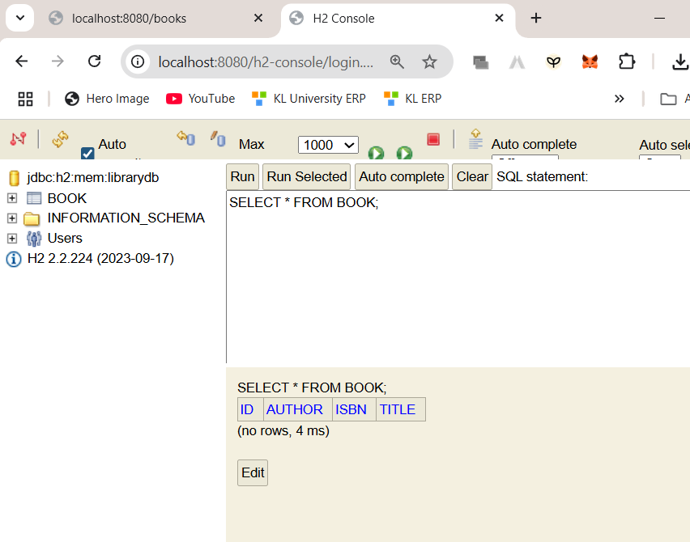
You will get to see this
curl -X POST http://localhost:8080/books -H "Content-Type: application/json" -d "{\"title\":\"The Alchemist\", \"author\":\"Paulo Coelho\", \"isbn\":\"9780061122415\"}"
try this on your cmd
you will see output in your terminal instead on POSTMAN
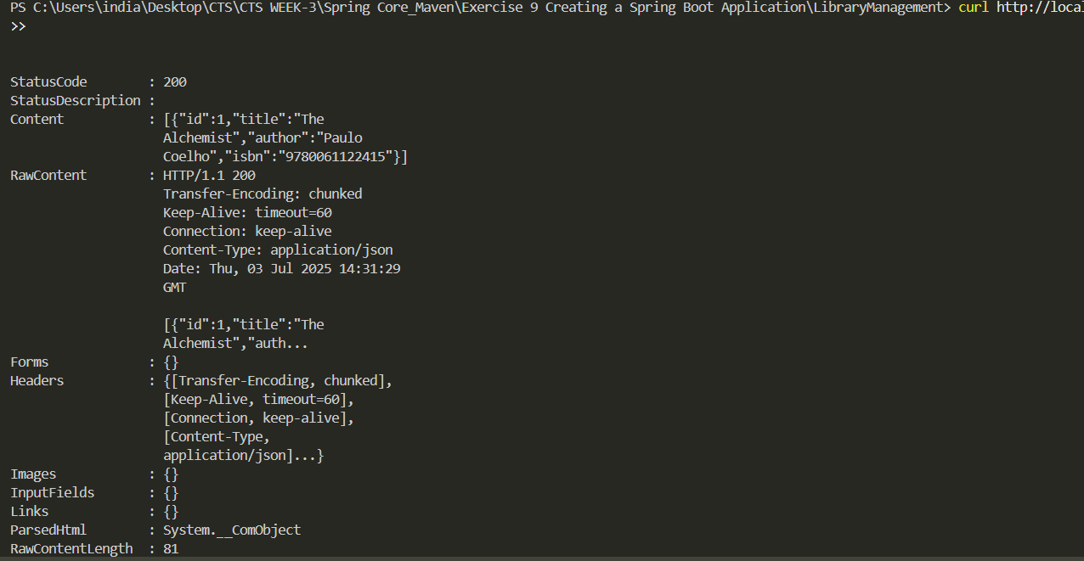see the content you get the book 1 data
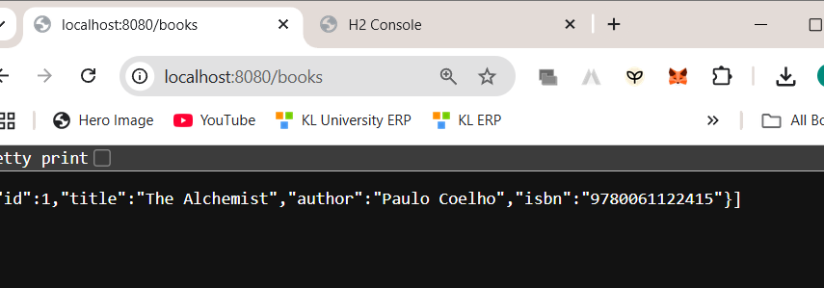
Dependencies used
Spring Web, Spring Data JPA, and H2 Database
Create Application Properties
# H2 in-memory DB
spring.datasource.url=jdbc:h2:mem:librarydb
spring.datasource.driverClassName=org.h2.Driver
spring.datasource.username=sa
spring.datasource.password=

spring.jpa.database-platform=org.hibernate.dialect.H2Dialect
spring.jpa.hibernate.ddl-auto=update

spring.h2.console.enabled=true
spring.h2.console.path=/h2-console

Define Entities and Repositories:
package com.example.librarymanagement.model;

import jakarta.persistence.Entity;
import jakarta.persistence.GeneratedValue;
import jakarta.persistence.GenerationType;
import jakarta.persistence.Id;

@Entity
public class Book {
@Id
@GeneratedValue(strategy = GenerationType.IDENTITY)
private Long id;

private String title;
private String author;
private String isbn;

// Getters & setters
public Long getId() { return id; }
public void setId(Long id) { this.id = id; }

public String getTitle() { return title; }
public void setTitle(String title) { this.title = title; }

public String getAuthor() { return author; }
public void setAuthor(String author) { this.author = author; }

public String getIsbn() { return isbn; }
public void setIsbn(String isbn) { this.isbn = isbn; }
}

package com.example.librarymanagement.repository;

import com.example.librarymanagement.model.Book;
import org.springframework.data.jpa.repository.JpaRepository;

public interface BookRepository extends JpaRepository<Book, Long> {
}

Create a REST Controller:
package com.example.librarymanagement.controller;

import com.example.librarymanagement.model.Book;
import com.example.librarymanagement.repository.BookRepository;
import org.springframework.beans.factory.annotation.Autowired;
import org.springframework.web.bind.annotation.*;

import java.util.List;

@RestController
@RequestMapping("/books")
public class BookController {

@Autowired
private BookRepository bookRepository;

@GetMapping
public List<Book> getAllBooks() {
return bookRepository.findAll();
}

@GetMapping("/{id}")
public Book getBookById(@PathVariable Long id) {
return bookRepository.findById(id).orElse(null);
}

@PostMapping
public Book createBook(@RequestBody Book book) {
return bookRepository.save(book);
}

@PutMapping("/{id}")
public Book updateBook(@PathVariable Long id, @RequestBody Book bookDetails) {
Book book = bookRepository.findById(id).orElse(null);
if (book != null) {
book.setTitle(bookDetails.getTitle());
book.setAuthor(bookDetails.getAuthor());
book.setIsbn(bookDetails.getIsbn());
return bookRepository.save(book);
}
return null;
}

@DeleteMapping("/{id}")
public void deleteBook(@PathVariable Long id) {
bookRepository.deleteById(id);
}
}

